Sample Final HEInnovate Report

Section 1: HEInnovate Dimensions
Section 2: Specific Question Responses
Section 3: Action Planning Elements identified through HEInnovate

Section 1 HEInnovate Dimensions
Comment
The following analysis and commentary is derived from work undertaken by THE UNIVERSITY over the three year GITA project period. The HEInnovate survey tool was used as part of the university’s endeavour to introduce entrepreneurial practices and supporting structures within the university. THE UNIVERSITY used the HEInnovate tool at the commencement of the project to baseline the initial entrepreneurial orientation and to identify useful activities and tasks to further the implementation of entrepreneurial activity. Prior to the 2020 survey, an additional dimension, Digital Transformation and Capability, was added to the survey tool for which there was not a 2017 measure.

The following are the dimension scores for the 2021 diagnostic survey.
HEInnovate Dimensions | Dimension Score 2021
1. Leadership and Governance | 3.54
2.Organisational Capacity: Funding, People and Incentives | 3.52
3.Entrepreneurial Teaching and Learning | 3.64
4.Preparing and Supporting Entrepreneurs | 3.42
5. Digital Transformation and Capability | 3.54
6. Knowledge Exchange and Collaboration | 3.50
7. The Internationalised Institution | 3.46
8. Measuring Impact | 3.35

Dimension 1: Leadership & Governance
Comment:
Overall respondents recorded a score of 3.54 out of 5 for ‘Leadership and Governance’ regarding the university’s perceived entrepreneurial orientation, with strong confirmation of the university’s model in place for coordinating and integrating entrepreneurial activities across the organisation. In addition respondents reported that there is a commitment at a high level to implementing the entrepreneurial agenda.
The lowest score of 3.4 was reported on the perception that ‘the university encourages and supports faculties and units to act entrepreneurially’, This is somewhat surprising given the major initiatives such as the Growth Hub and Incubation unit put in place over the project period. Perhaps increasing the visibility and awareness of the range and extend to the university’s entrepreneurial initiatives more widely through the web portal and traditional channels would increase the reported score.

Analyses:
The following are the component question area scores which underpin the ‘Leadership and Governance’ dimension perception of respondent groups. There is a strong a view that the university has a model in place for coordinating and integrating entrepreneurial activities. There is perhaps an opportunity for the university to play a greater role promoting and supporting entrepreneurial initiatives regionally through active collaboration with external industry partners.

Dimension Measurement Questions | Score
- Entrepreneurship is a major part of the HEI’s strategy. | 3.5
- There is commitment at a high level to implementing the entrepreneurial agenda | 3.6
- There is a model in place for coordinating and integrating entrepreneurial activities across the HEI. | 4.7
- The HEI encourages and supports faculties and units to act entrepreneurially. | 3.4
- The HEI is a driving force for entrepreneurship and innovation in regional, social and community development. | 3.5

Action Plan Objectives:
- Continued commitment at a high level of the university to implementing the entrepreneurial agenda.
- A co-ordinated communications project to raise the awareness of the range and extent of entrepreneurial activities among respondents across the university faculties and among external stakeholders.
- Promote the Growth Hub and incubator unit across the university and promote collaboration with alumni and external stakeholders.
- Develop and implement an ongoing review process and guideline to generate responses to the disclosed gaps in the HEInnovate analysis.
- The eight dimensions of HEInnovate will now become a guidance process for our Growth Hub strategic plan
- HEInnovate will become the regular instrument for periodic assessment in University & Study program Level.

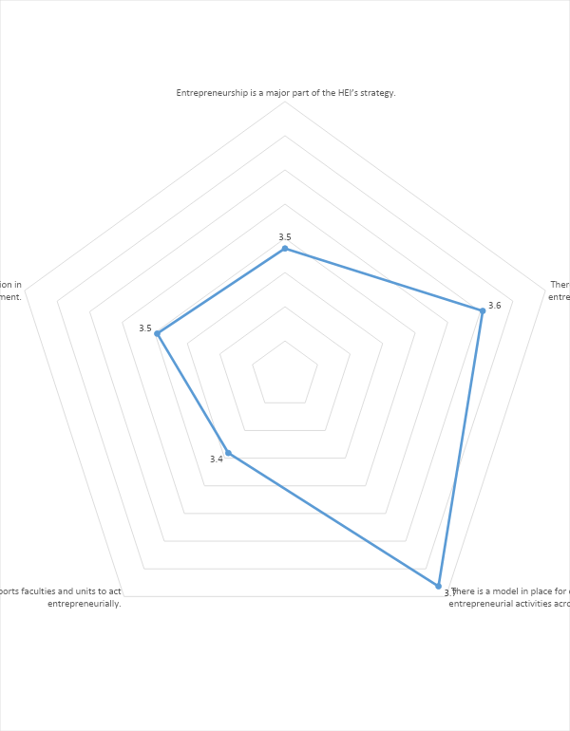

Dimension 2: Organisational Capacity: Funding, people and Incentives
Comment:
Overall respondents recorded a score of 3.52 out of 5 for ‘Organisational Capacity: Funding, people and Incentives’ for the university’s perceived entrepreneurial orientation. Respondent groups view strongly that the university’s ‘entrepreneurial objectives are supported by a wide range of sustainable funding and investment sources’ and that the university is ‘is open to engaging and recruiting individuals with entrepreneurial attitudes, behaviour and experience’.
Areas for attention probably relate to investing, supporting and incentivising staff who actively support the entrepreneurial agenda through their educational an industry engagement activities.

Analyses:
The following are the component question area scores which underpin the ‘Organisational Capacity: Funding, people and Incentives’ dimension as perceived by respondent groups.
There is a strong a view that the university supports entrepreneurial objectives through a wide range of ‘sustainable funding and investment sources’ as well ‘engaging and recruiting individuals with entrepreneurial attitudes, behaviour and experience’. Both of which strengthen the university’s entrepreneurial agenda.

Dimension Measurement Questions | Score
- Entrepreneurial objectives are supported by a wide range of sustainable funding and investment sources. | 3.7
- The HEI has the capacity and culture to build new relationships and synergies across the institution. | 3.5
- The HEI is open to engaging and recruiting individuals with entrepreneurial attitudes, behaviour and experience. | 3.6
- The HEI invests in staff development to support its entrepreneurial agenda. | 3.4
- Incentives and rewards are given to staff who actively support the entrepreneurial agenda | 3.4

Action Plan Objectives:
- Promote the development and availability of the Growth Hub, and Incubation Unit internally to students, staff and management and externally to industry partners and potential users.
- Support the development of staff with training and investment to enhance the university’s entrepreneurial engagement initiatives.
- Support the development of staff with training and investment to enhance the university’s entrepreneurial teaching and learning initiatives and ELO adoption.
- Encourage and support staff mobility and collaboration with national and international academic and industry partners.

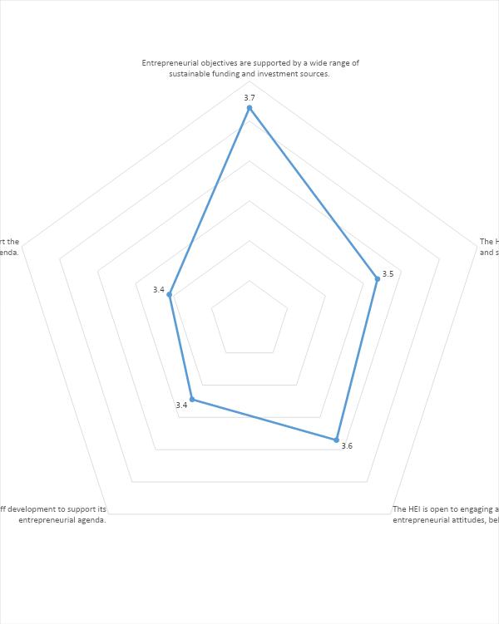

Dimension 3: Entrepreneurial Teaching and Learning
Comment:
Overall respondents recorded a score of 3.64 out of 5 for ‘Entrepreneurial Teaching and Learning’. With a high score for the view that the university ‘provides diverse formal learning opportunities to develop entrepreneurial mind-sets and skills’ this is probably in response to the ELO, Growth Hub and Incubation initiatives implemented over the past three years. The respondent scores for each of the component measures indicate the university to actively developing and implementing effective entrepreneurial educational learning opportunities.

Analyses:
The following are the component question area scores which underpin the ‘Entrepreneurial Teaching and Learning’ dimension as perceived by respondent groups.
The dimension and component scores of 3.6 indicate the respondents view the university as having a positive entrepreneurial orientation in respect of the teaching and learning agenda. This is a strong position on which to build and extend the opportunities of an entrepreneurial learning experience across the faculties.

Dimension Measurement Questions | Score
- The HEI provides diverse formal learning opportunities to develop entrepreneurial mind-sets and skills. | 3.8
- The HEI provides diverse informal learning opportunities and experiences to stimulate the  development of entrepreneurial mind-sets and skills. | 3.6
- The HEI validates entrepreneurial learning outcomes which drives the design and execution of the entrepreneurial curriculum. | 3.6
- The HEI co-designs and delivers the curriculum with external stakeholders.  Results of entrepreneurship research are integrated into the entrepreneurial education offer. | 3.6
- Results of entrepreneurship research are integrated into the entrepreneurial education offer. | 3.6

Action Plan Objectives:
- Entrepreneurial education agenda has been mainstreamed to increase the university’s organizational capacity in teaching and learning.
- Based on HEInnovate assessment, the university roll out the mapping throughout university (25 study programs) in 2021.
- Continue to expand the ELO curriculum initiative to introduce entrepreneurial learning opportunities to more programmes and faculties.
- Promote the use of the Growth Hub and business incubation facilities widely across the university.
- Collaborate with GITA partner universities through the National Association to enhance teaching and learning collaboration through initiatives such as student enterprise competitions, staff case development workshops, Joint conferences, workshops and webinars.
- Actively participate in the development and use of the GITA Web Portal.

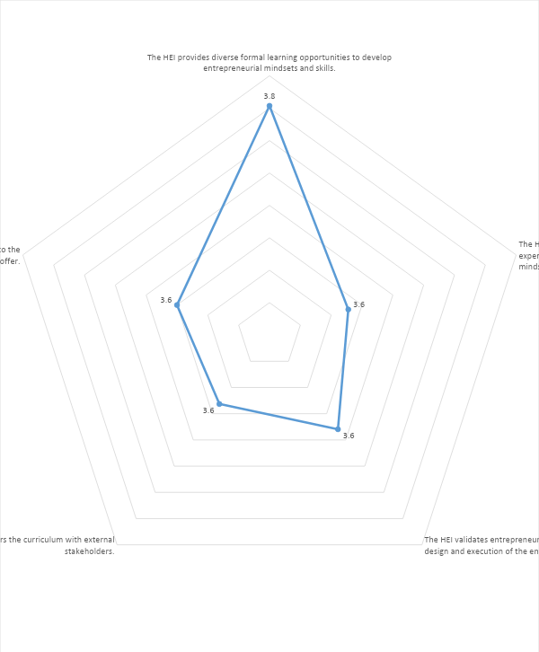

Dimension 4: Preparing and Supporting Entrepreneurs
Comment:
Overall, respondents recorded a score of 3.42 out of 5 for ‘Preparing and Supporting Entrepreneurs’. The introduction of the Growth Hub and the incubation unit will have contributed to the university’s infrastructure support for entrepreneurs.
Organisationally the university has created a directorate with significant university, government and industry budget support for preparing and supporting entrepreneurial activities. The availability of support grants through the university infrastructure using a competitive process has already attracted approximately 500 inventors in 150 start-up candidacies.

Analyses:
The following are the component question area scores which underpin the ‘Preparing and Supporting Entrepreneurs’ dimension as perceived by respondent groups.
The reported perception of the underlying component scores seem low in relation to the amount of work and the entrepreneurial initiatives implemented by the university over the past three years. Consideration of an ongoing communications channel to raise awareness across the university and among external stakeholders would be of benefit. Awareness of the infrastructural, grant aid, educational supports, Growth Hub, and incubation initiatives through online and traditional channels of communication should be prioritised.

Dimension Measurement Questions | Score
- The HEI increases awareness of the value of entrepreneurship and stimulates the entrepreneurial intentions of students, graduates and staff to start-up a business or venture. | 3.6
- The HEI supports its students, graduates and staff to move from idea generation to business creation. | 3.4
- Training is offered to assist students, graduates and staff in starting, running and growing a business. | 3.5
- Mentoring and other forms of personal development are offered by experienced individuals from academia or industry. | 3.3
- The HEI facilitates access to financing for its entrepreneurs | 3.2
- The HEI offers or facilitates access to business incubation | 3.5

Action Plan Objectives:
- The Growth Hub has been established as a new Directorate for Entrepreneurial Development.
- Promote the use of the Growth Hub and business incubation facilities widely across the university and among alumni and external business organisations.
- The building of strong educational relationship with industry and commercial business
- The eight dimensions of HEInnovate will now become a guidance process for our Growth Hub strategic plan
- A start-up grant support initiative has been established to assess and distribute grant supports. The initiative has already attracted 500 inventors in 150 start-up candidacies.
- Develop the business start-up and advisory relationship with local/regional government agencies and financial institutions.
- Develop start-up business planning and research workshops through the Growth Hub to support early stage entrepreneurs.
- Develop the number and scale of collaboration with external business partners, to provide industry mentoring, consultancy and advisory support to students and supporting academic staff.
- A co-ordinated communications project to raise the awareness of the range and extent of entrepreneurial activities among respondents across the university and among external stakeholders.
- Promote the incubator and make collaboration with alumni.
- Encourage a continuing commitment at a high level to implement the entrepreneurial agenda
- Develop and implement an entrepreneurial collaboration programme with Alumni, Coop, SME departments, companies and universities

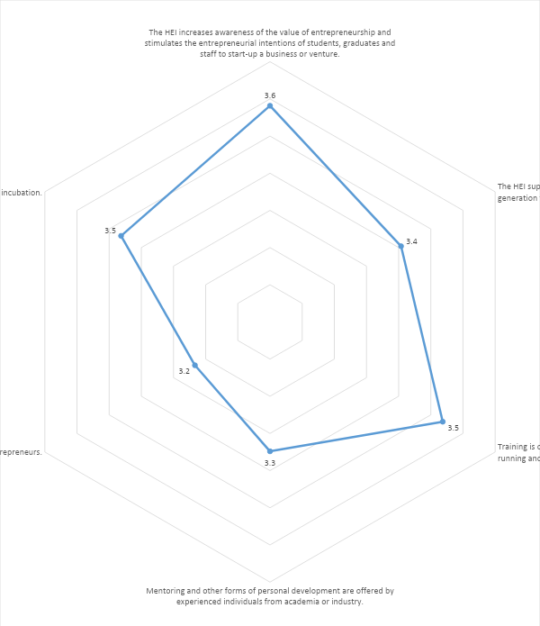

Dimension 5: Digital Transformation and Capability

Comment:
Overall respondents recorded a score of 3.54 out of 5 for ‘Digital Transformation and Capability’. The Covid-19 situation has required all universities world-wide to re-configure their educational and engagement activities. Academic staff and university leadership have been dynamically responding to radical changes in their learning and engagement environments. The respondent scores confirm respondent’s perceptions that the university is ‘committed to digital teaching, learning and assessment’ and that the ‘digital infrastructure is planned, managed and continuously improved in alignment with the vision, mission and strategy of the university’. A university’s digital engagement and educational capability is the new expected standard for all universities. The development of a coherent digital policy, infrastructure, culture, and staff capability are required investments for all educational providers.
Analyses:
The following are the component question area scores which underpin the ‘Organisational Capacity: Funding, people and Incentives’ dimension as perceived by respondent groups.
The analysis confirms the university’s commitment to digital teaching, learning and assessment practices and infrastructure in support of the entrepreneurial agenda and in response to the changing educational and engagement requirements of educational providers.

Dimension Measurement Questions | Score
- The HEI fosters a digital culture as a mean for innovation and entrepreneurship | 3.4
- The digital infrastructure is planned, managed and continuously improved to align with the vision, mission and strategy of the innovative HEI. | 36
- The HEI is committed to digital teaching, learning and assessment practices. | 37
- Open science and innovation practices are widespread across the HEI. | 3.4
- The HEI has a dynamic digital presence supporting all its activities. | 3.6

Action Plan Objectives:
- Incorporate ‘Digital Transformation’ into the main program in the University’s Strategic Plan.
- Develop the university’s digital infrastructure to support students, staff and external partners in delivering the educational mission.
- Develop the university’s online educational model through staff and student training and infrastructure investment.
- Use the Web portal to develop and develop and disseminate entrepreneurial materials and communicates to students, staff, management and external stakeholders.
- Enhance collaboration with external business partners and universities through cooperative online seminars, workshops and conferences.
- Promote the university’s entrepreneurial agenda and specific entrepreneurial initiatives through high quality online communications with internal and external stakeholders.

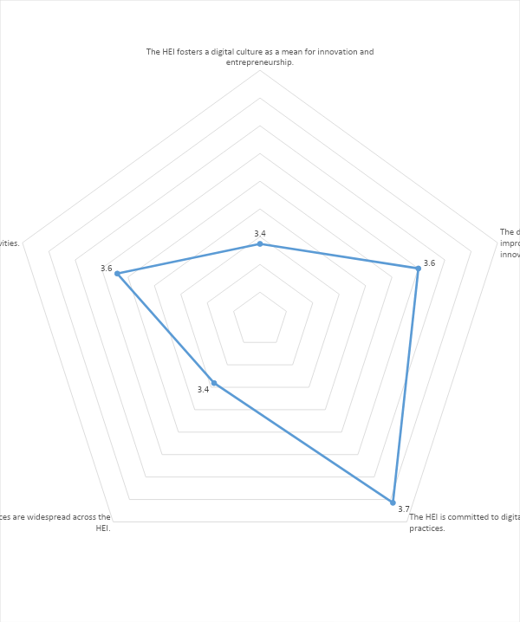

Dimension 6: Knowledge Exchange and Collaboration
Comment:
Overall respondents recorded a score of 3.50 out of 5 for ‘Knowledge Exchange and Collaboration’. The respondent scores indicate that the university is committed to collaboration and knowledge exchange and facilitates engagement and learning opportunities for students and staff through research, workshops, conferencing and experiential learning initiatives. The university has been successful in securing additional funding for business start-up initiatives through collaboration industry and government support.

Analyses:
The following are the component question area scores which underpin the ‘Knowledge Exchange and Collaboration’ dimension as perceived by respondent groups.
The respondent score of 3.5/3.6 for the majority of component measures confirms the university’s commitment to knowledge exchange and collaboration. The component score of 3.3 for the university’s ‘links with incubators, science parks and other external initiatives’ is a little low and may well be addressed as the full effect of the Growth Hub, Incubation Unit and external engagement with industry and academic partners in entrepreneurial activity increases.

Dimension Measurement Questions | Score
- The HEI is committed to collaboration and knowledge exchange with industry, the public sector and society. | 3.6
- The HEI demonstrates active involvement in partnerships and relationships with a wide range of stakeholders. | 3.5
- The HEI has strong links with incubators, science parks and other external initiatives. | 3.3
- The HEI provides opportunities for staff and students to take part in innovative activities with business / the external environment. | 3.6
- The HEI integrates research, education and industry (wider community) activities to exploit new knowledge. | 3.6

Action Plan Objectives:
- Develop active external relationships with industry and academic partners, nationally and internationally through MOUs and MOAs.
- Increase collaboration with GITA network partners through the National Association.
- Within the university, promote the entrepreneurial education agenda across faculties and throughout the management structure of the university.
- Active participation in the National association to provide experiential learning opportunities for students and development and networking opportunities for academic staff.
- Encourage and support staff to participate in national and international entrepreneurship networks, conferences and research consortia.
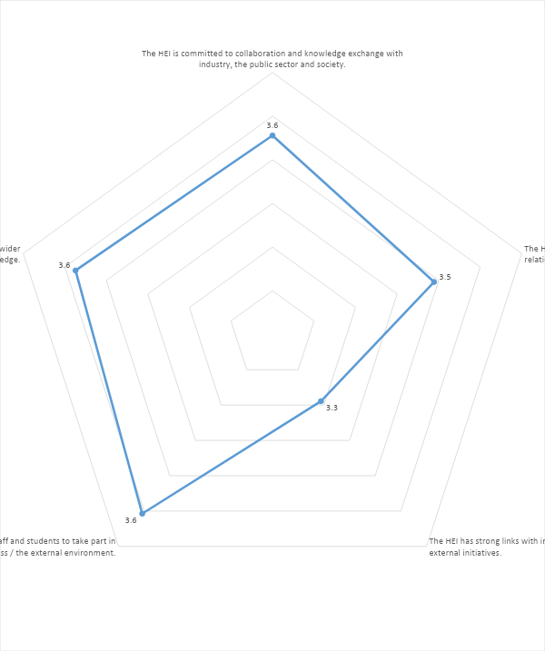

Dimension 7: The Internationalised Institution
Comment:
Overall respondents recorded a score of 3.46 out of 5 for ‘The Internationalised Institution’.
Respondents scored the university to have a moderate orientation towards internationalisation, with scores between 3.2 and 3.7, indicating an opportunity to increase the range and extent of internationalisation initiatives, from research, teaching and learning collaboration, staff and student mobility and MOUs. The entrepreneurial agenda of a university requires a strong internationalisation policy through which research and learning collaboration as well as international networking can enhance the university’s position.
Analyses:
The lowest score of 3.2 was reported on the perception that ‘the university seeks and attracts international and entrepreneurial staff’. The encouragement of inbound and outbound staff mobility on short to medium duration assignments could address the perception if it is held to have merit.

Dimension Measurement Questions | Score
- Internationalisation is an integral part of the HEI’s entrepreneurial agenda.
- The HEI explicitly supports the international mobility of its staff and students.
- The HEI seeks and attracts international and entrepreneurial staff.
- International perspectives are reflected in the HEI’s approach to teaching.
- The international dimension is reflected in the HEI’s approach to research.

Action Plan Objectives:
- Support International staff and student mobility for participation in entrepreneurial research, networking, workshops and education learning opportunities.
- Develop collaboration and cooperation agreements with international universities through MOUs and MOAs to enhance staff and student exchange, research and publication arrangements, conferencing and seminars.
- Explore the development student and staff involvement in international enterprise competitions and ‘boot-camps’.
- Promote and develop the National Association as the international platform representing Indonesia’s entrepreneurial university partners.

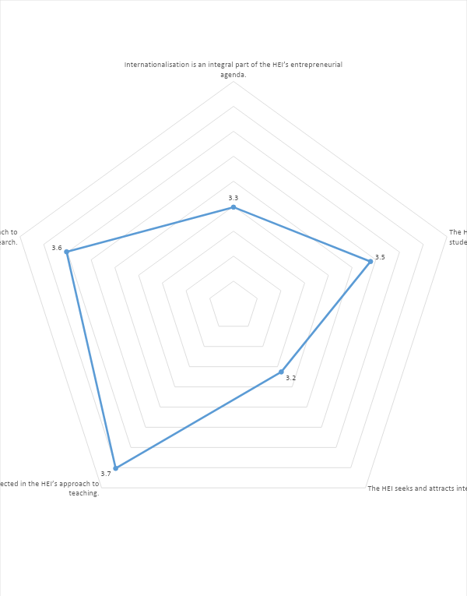

Dimension 8: Measuring Impact
Comment:
Overall respondents recorded a score of 3.50 out of 5 for ‘Measuring Impact’
Evaluating the effectiveness of entrepreneurial initiatives require measurement against objective criteria. Measuring the impact of entrepreneurial activities on the university’s capability and it’s perception among stakeholders is an important activity. The measurement of impact is a continuing activity required to underpin the organisational action planning and entrepreneurial educational process. The adoption of the practice of measurement against criteria as a routine is fundamental to the entrepreneurial orientation for each and all initiatives.
The 2021 analysis indicates that the university is perceived among respondent groups to regularly assesses entrepreneurial teaching and learning across the institution’, but could improve its component scores in two other areas, namely the ‘assessment of the impact of its entrepreneurial agenda’ and ‘how its personnel and resources support its entrepreneurial agenda’.
Analyses:
The 2021 analysis indicates that the university is perceived among respondent groups to regularly assesses entrepreneurial teaching and learning across the institution’, but could improve its component scores in two other areas, namely the ‘assessment of the impact of its entrepreneurial agenda’ and ‘how its personnel and resources support its entrepreneurial agenda’.
Ongoing support for the entrepreneurial agenda and enterprise engagement initiatives depends on establishing the value and efficacy of the commitment of the university’s time, energy and resources. The adoption of a routine policy of measurement and review against project criteria is a requirement for effective implementation and management of entrepreneurial initiatives.

Action Plan Objectives:
- To regularly undertake a HEInnovate assessment to benchmark entrepreneurial orientation progress, facilitate project team discussion and action planning.
- Develop a standardised template for the measurement and evaluation of entrepreneurial initiatives and projects against objective criteria.
- Publish the evaluation reports on entrepreneurial initiatives and projects to facilitate clear communication to university management, academic staff and external stakeholders.
- Develop an ongoing entrepreneurial advocacy group to build awareness among university stakeholders and external partners.
- Active participation with the National Association to build a strong entrepreneurial education voice.
- Research and publish reports and metrics relating to entrepreneurial education which can contribute to national educational policy.

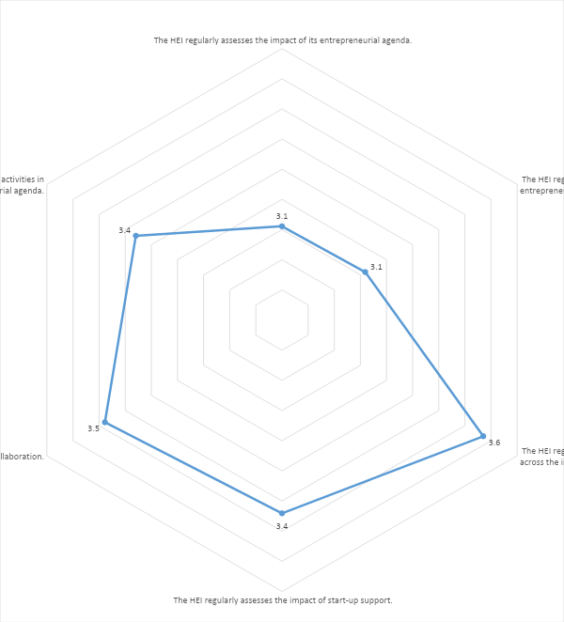

Section 2: Specific Question Responses

 | Report Section
1 | The use and usefulness of HEInnovate
1a | Commentary on the HEInnovate process as a way of improving university/department activities
1b | Perhaps some examples of changes in university/department as a result of working with the HEInnovate process.
2 | The Methodology employed to implement HEInnovate
2a | How did the university deploy the HEInnovate process
2b | What worked / what did not work
2c | What improvements could you suggest based on your experience with the HEInnovate process?
3 | The impact the HEInnovate process for the university/department/etc.
3a | Identify and comment on elements included in the University/Department Action Plan, which were influenced by insights from the HEInnovate process.
3b | Whether the university/Department’s orientation has been influenced by using the HEInnovate process.
3c | Comment on whether you feel that the HEInnovate process could be included as part of the university/department’s ongoing practice, and if so how?

1. The use and usefulness of HEInnovate

1a. Commentary on the HEInnovate process as a way of improving university/department activities

After a full cycle of HEInnovate implementation (survey, report generation, and analysis of gaps and disclosing the critical area of intervention), we learned that the result of HEInnovate would help the institution to refine the business process toward a more innovative higher education service provider.

However, we also revealed that a further tool to generate recommendation is still missing from the HEInnovate. Therefore, THE UNIVERSITY - with a purpose to help every unit/department in making the best use of survey have developed a guideline to generate a program according to the disclosed gaps in the HEInnovate analysis.

1b. some examples of changes in university/department as a result of working with the HEInnovate process.

Two period of HEInnovate survey have been conducted, first, in the beginning of GITA project, and the second was in the last year of GITA project. In the first period HEInnovate survey, the lowest point was the area of Digital Transformation and Capability. To address this gap, the university – led by new Rectorate for the period of 2018-2022 – has pushed forward the Digital Transformation into the main program in the University’s Strategic Plan. As the result at the second period of HEInnovate we found that the most influential area of transformation that has taken place is in the aspect of Digital Transformation and Capability.

With consider that other factors are equally important, the university has also changed the organization structure from previously which had only three areas of management, i.e. academic, administrative, and student affair. To these areas have been added with a new structure of entrepreneurial development & institutional networking. Under this new governance, the THE UNIVERSITY’s Growth Hub is established as a new Directorate for Entrepreneurial Development.

The new structure implies a new requirement of leadership and governance to allow for building a strong educational relationship with industry and commercial business, but also aims to keep the university as non-for-profit organization. Under this new structure, series of program to increase organizational capacity on teaching and learning on the entrepreneurial aspect have been mainstreamed.

Moreover, HEInnovate’s 8 ‘Dimensions’ now become a good guidance for our Growth Hub strategic plan. Based on HEInnovate assessment, the university roll out the mapping throughout university (25 study programs) in 2020. The respondents are more varied such as, lecturers, professional staff/administration and student. It shows that the eagerness to do self-assessment increased. Next, HEInnovate will become the regular instrument for periodic assessment in University & Study program Level.

2. The Methodology employed to implement HEInnovate

2a. How did the university deploy the HEInnovate process

Two approaches for HEInnovate process have been applied. At the first round of HEInnovate survey, we only set one group of survey, at university level, to obtain first figure of university performance. It provides an aggregated information at the university level.

When the intervention should go to the lower level of unit, e.g. the department, some information could not be revealed easily. Therefore, in the second round of survey we make a sub-group at the level of Study Program. The main objective of this approach is to allows specific intervention at Study Program level.

The second round of HEInnovate were implemented with following stages:

- The Growth Hub team, arrange a plan of inserting HEInnovate questionnaire as one of essential instrument of Entrepreneurial University and Entrepreneurial Learning Outcome (ELO) development.
- We put HEInnovate Mapping as the basic requirement for ELO Grant Proposal of 25 Study Program of THE UNIVERSITY.
- We arranged a virtual workshop (for 2 hours) for fulfilling of HEInnovate Assessment.
- We arranged a virtual assistance (for 4 days) for fulfilling HEInnovate Assessment.
- We compiled the raw data from HEI website into a University Report for internal use of strategic planning.

2b. What worked / what did not work

While transformation requires a top-down approach, further gap analysis and intervention should go to lower-level unit. Therefore, if the transformation has been started, for example in THE UNIVERSITY, when the leadership and governance including all university level has been transformed, and lower-level intervention is required, the aggregated data for only one group (at university level) will not applicable.

2c. What improvements could you suggest based on your experience with the HEInnovate process?

Hence, we strongly suggest that to serve more specific purpose at department level, as well as general purpose at university level, the survey should be designed as part of combining approach of top-down and bottom-up process.

- The impact the HEInnovate process for the university/department/etc.

At the university level the HEInnovate has influenced the decision to change the structure of organization, and the governance approaches. The significant changes are not only at the Rectorate, but also at Directorate, and Sub-Directorate (Division) Levels. The structural changes could secure university budget to allocate for the transformation.

Specific for entrepreneurial aspect, at least EUR 58,000 internal budget has been allocated to the Directorate level for preparing and supporting entrepreneurial activities. The impact to this support could be measured by external budget from government and industry at about three time of the investment. Even. the collaboration activity with the government for example, has attracted grants of about EUR 232,129.
The grants have been distributed to the start-up from department level. The grants allocation has been also implemented with a competitive process that able to attract about 500 inventors in 150 start-up candidacies.

3a. Identify and comment on elements included in the University/Department Action Plan which were
influenced by insights from the HEInnovate process.

The ideas and objective and experiences from HEInnovate process have been included in The Foundation’s Strategic Direction 2018-2020, and the University Strategic Planning 2018-2022. The document is a part of alignment process with the reference of THE UNIVERSITY’s Master Plan 2008-2038. The insight from HEInnovate process is one of the influencing factors of the Strategic Planning that should accommodate the dynamic and trend of education ecosystems.

3b. Whether the university/Department’s orientation has been influenced by using the HEInnovate
process.

The most influenced orientation is the transformative process of THE UNIVERSITY from previously aims to Teaching and Research University to the next level of Entrepreneurial University.

3c. Comment on whether you feel that the HEInnovate process could be included as part of the university/department’s ongoing practice, and if so how?

HEInnovate is one of the essential instruments for the Growth Hub to develop the entrepreneurial development among study program in THE UNIVERSITY. In Year 2020, we create an Entrepreneurial Learning Outcome (ELO) Assessment for each of our study programs, and HEInnovate method is really match with the needs of entrepreneurial development in THE UNIVERSITY.

Moreover, currently the HEInnovate become one of the requirements for the University Grant for Entrepreneurial Transformation.

Section 3: Action Planning Objectives identified through HEInnovate
Action Planning Elements identified through HEInnovate
The following table outlines the tasks / activities / projects which THE UNIVERSITY – THE UNIVERSITY’s GITA project team have identified and are implementing as part of the GITA process to facilitate the development of an entrepreneurial orientation within the university.
The analysis of each dimension, when considered by the university project team identifies a task / activity / project for implementation. Target dates, responsibilities and achievement criteria are required to complete the process.
Dimension | Action Plan Objective | Target Completion Date
Dimension 1: Leadership and Governance | - Continue to promote the entrepreneurial agenda and support initiatives to embed an entrepreneurial mind set and skill set throughout the university.
 | - A co-ordinated communications project to raise the awareness of the range and extent of entrepreneurial activities among respondents across the university faculties and among external stakeholders.
 | - Promote the Growth Hub and incubator unit across the university and promote collaboration with alumni and external stakeholders.
 | - Develop and implement an ongoing review process and guideline to generate responses to the disclosed gaps in the HEInnovate analysis.
 | - The eight dimensions of HEInnovate will now become a guidance process for our Growth Hub strategic plan
 | - HEInnovate will become the regular instrument for periodic assessment in University & Study program Level.
Dimension 2: Organisational Capacity: Funding, People and Incentives | - Collaborate with GITA partner universities through the national association to enhance organisational capacity through cooperation in entrepreneurial initiatives.
 | - Entrepreneurial education agenda has been mainstreamed to increase the university’s organizational capacity in teaching and learning
 | - Promote the development and availability of the Growth Hub, and Incubation Unit internally to students, staff and management and externally to industry partners and potential users.
 | - Support the development of staff with training and investment to enhance the university’s entrepreneurial engagement initiatives.
 | - Support the development of staff with training and investment to enhance the university’s entrepreneurial teaching and learning initiatives and ELO adoption.
 | - Encourage and support staff mobility and collaboration with national and international academic and industry partners.
Dimension 3: Entrepreneurial Teaching Capacity | - Entrepreneurial education agenda has been mainstreamed to increase the university’s organizational capacity in teaching and learning.
 | - Based on HEInnovate assessment, the university roll out the mapping throughout university (25 study programs) in 2021.
 | - Continue to expand the ELO curriculum initiative to introduce entrepreneurial learning opportunities to more programmes and faculties.
 | - Promote the use of the Growth Hub and business incubation facilities widely across the university.
 | - Collaborate with GITA partner universities through the National Association to enhance teaching and learning collaboration through initiatives such as student enterprise competitions, staff case development workshops, Joint conferences, workshops and webinars.
 | - Actively participate in the development and use of the GITA Web Portal.
Dimension 4:  Preparing and Supporting Entrepreneurs | - The Growth Hub has been established as a new Directorate for Entrepreneurial Development.
 | - Promote the use of the Growth Hub and business incubation facilities widely across the university and among alumni and external business organisations.
 | - The building of strong educational relationship with industry and commercial business
 | - The eight dimensions of HEInnovate will now become a guidance process for our Growth Hub strategic plan
 | - A start-up grant support initiative has been established to assess and distribute grant supports. The initiative has already attracted 500 inventors in 150 start-up candidacies.
 | - Develop the business start-up and advisory relationship with local/regional government agencies and financial institutions.
 | - Develop start-up business planning and research workshops through the Growth Hub to support early stage entrepreneurs.
 | - Develop the number and scale of collaboration with external business partners, to provide industry mentoring, consultancy and advisory support to students and supporting academic staff.
 | - A co-ordinated communications project to raise the awareness of the range and extent of entrepreneurial activities among respondents across the university and among external stakeholders.
 | - Promote the incubator and make collaboration with alumni.
 | - Encourage a continuing commitment at a high level to implement the entrepreneurial agenda.
 | - Develop and implement an entrepreneurial collaboration programme with Alumni, Coop, SME departments, companies and universities
Dimension 5:  Digital Transformation & Capability | - Incorporate ‘Digital Transformation’ into the main program in the University’s Strategic Plan.
 | - Develop the university’s digital infrastructure to support students, staff and external partners in delivering the educational mission.
 | - Develop the university’s online educational model through staff and student training and infrastructure investment.
 | - Use the Web portal to develop and develop and disseminate entrepreneurial materials and communicates to students, staff, management and external stakeholders.
 | - Enhance collaboration with external business partners and universities through cooperative online seminars, workshops and conferences.
 | Promote the university’s entrepreneurial agenda and specific entrepreneurial initiatives through high quality online communications with internal and external stakeholders.
Dimension 6:  Knowledge Exchange & Collaboration | - Develop active external relationships with industry and academic partners, nationally and internationally through MOUs and MOAs.
 | - Increase collaboration with GITA network partners through the National Association.
 | - Within the university, promote the entrepreneurial education agenda across faculties and throughout the management structure of the university.
 | - Active participation in the National association to provide experiential learning opportunities for students and development and networking opportunities for academic staff.
 | - Encourage and support staff to participate in national and international entrepreneurship networks, conferences and research consortia.
Dimension 7: Internationalisation | - Support International staff and student mobility for participation in entrepreneurial research, networking, workshops and education learning opportunities.
 | - Develop collaboration and cooperation agreements with international universities through MOUs and MOAs to enhance staff and student exchange, research and publication arrangements, conferencing and seminars.
 | - Explore the development student and staff involvement in international enterprise competitions and ‘boot-camps’.
 | - Promote and develop the National Association as the international platform representing Indonesia’s entrepreneurial university partners
Dimension 8: Measuring Impact | - To regularly undertake a HEInnovate assessment to benchmark entrepreneurial orientation progress, facilitate project team discussion and action planning.
 | - Develop a standardised template for the measurement and evaluation of entrepreneurial initiatives and projects against objective criteria.
 | - Publish the evaluation reports on entrepreneurial initiatives and projects to facilitate clear communication to university management, academic staff and external stakeholders.
 | - Develop an ongoing entrepreneurial advocacy group to build awareness among university stakeholders and external partners.
 | - Active participation with the National Association to build a strong entrepreneurial education voice.
 | - Research and publish reports and metrics relating to entrepreneurial education which can contribute to national educational policy.

